SARDAR VALLABHBHAI NATIONAL INSTITUTE OF TECHNOLOGY, SURAT
DEPARTMENT OF CIVIL ENGINEERING
STRUCTURAL ENGINEERING SECTION
EARTHQUAKE ENGINEERING LABORATORY
Earthquake engineering (EEL) laboratory was established in the year 2020. The laboratory is located in the Department of Civil Engineering. The laboratory facilities are utilized by postgraduate students for their curriculum laboratory work. The research scholars mainly utilize it for the research and development activities. Set up like actuator is also used for some of the consultancy work. The laboratory has good potential to carry out research and generate revenue using calibration and testing work in future. List of equipment’s available in the laboratory is given below:
Sr. No. | Equipment Name
1 | SERVO HYDRAULIC ACTUATOR (CAPACITY- 100 kN)
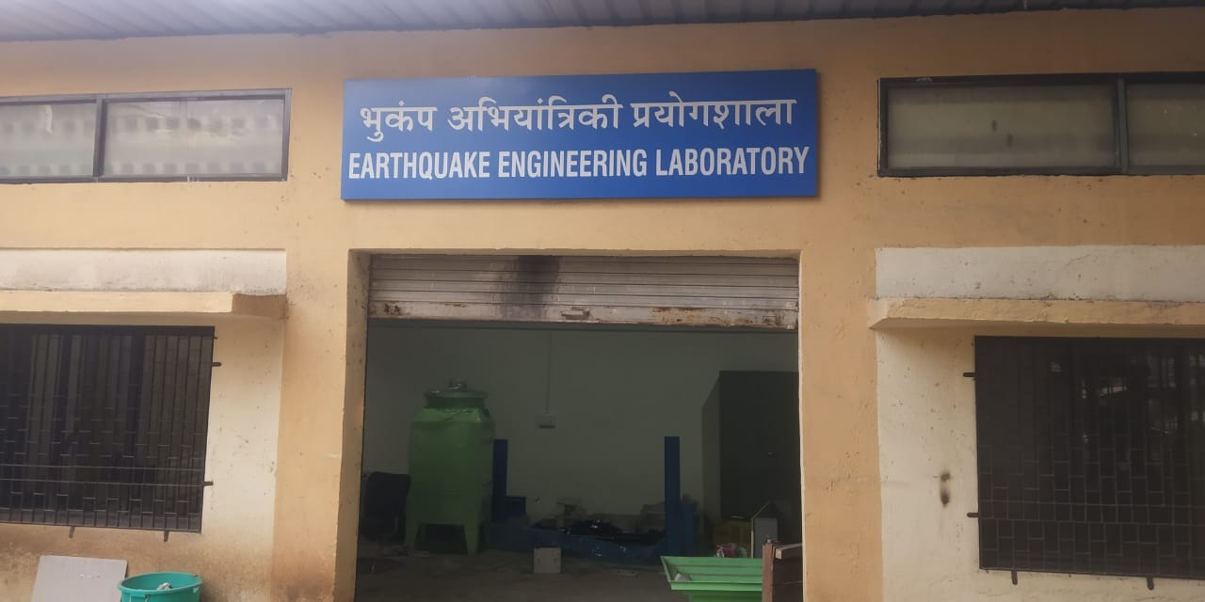
 | Figure 1 Earthquake Engineering Lab
Information Regarding Few Important Set Ups in the Earthquake Engineering Laboratory
Servo Hydraulic Actuator system (Model 244.22):
The set-up comprises of four main units; (i) Hydraulic Jack (ii) Hydraulic Power System (iii) Digital Controller (iv) MTS Computer with multiple Elite Software.
Hydraulic jack is used to provide dynamic action of load on the specimens. The Hydraulic jack can apply loads in both displacement and load -controlled mode to simulate various structural loading systems. These are essential loading equipment for simulating loading environment typical for earthquake; however, they can be used for gravity simulation as well. The maximum displacement or stroke length of the jack is 250 mm. As it can be used to apply cyclic load in tension as well as in compression testing. HPS is combine unit used to maintain the ambient temperature of the jack and other units. Water cooling system keep cool down the whole system while a standard hydraulic oil provided for lubrication. A digital system used to apply real time closed-loop control, with transducer conditioning and function generation to drive various types of servo-actuators, and supports a wide array of configurations including: axial and axial/torsional load units, uniaxial and multiaxial test systems, structural test actuators and electrodynamic systems. The MTS system PC is an integral part of the real-time control system and is extensively configured and tested to assure seamless integration with test system hardware and software which includes Microsoft office, Multipurpose Elite Software, data acquisition (timed, P/V, level crossing, cyclic/logarithmic, sine, square, triangle, ramp, hold, profile and custom waveform data) The figures of various units are given below;
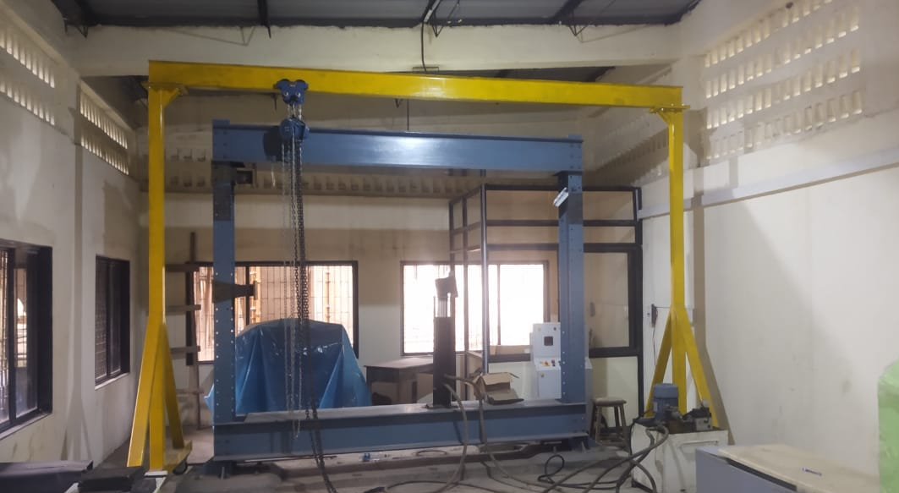
Figure 2 Loading Frame (Capacity-70 Ton)

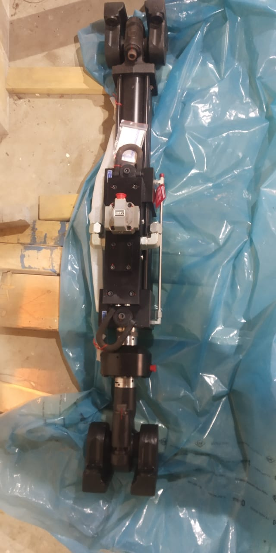
Figure 3 Servo Hydraulic Actuator
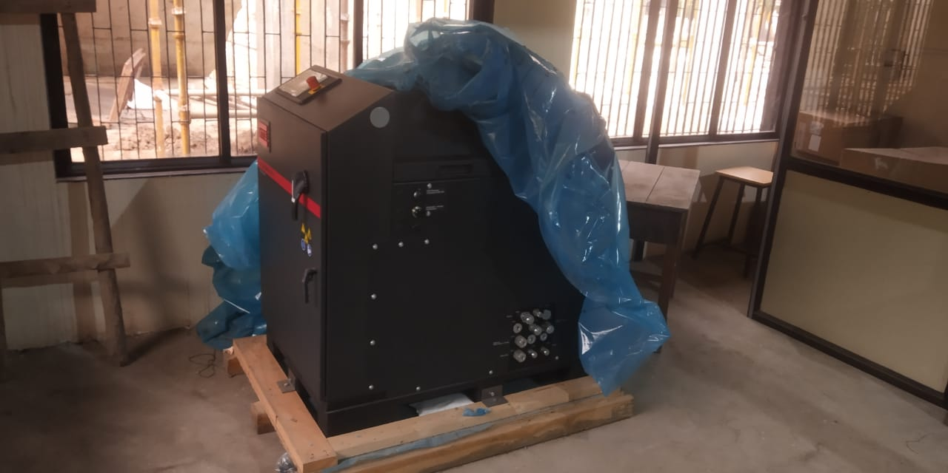
Figure 4 HPS Control Unit

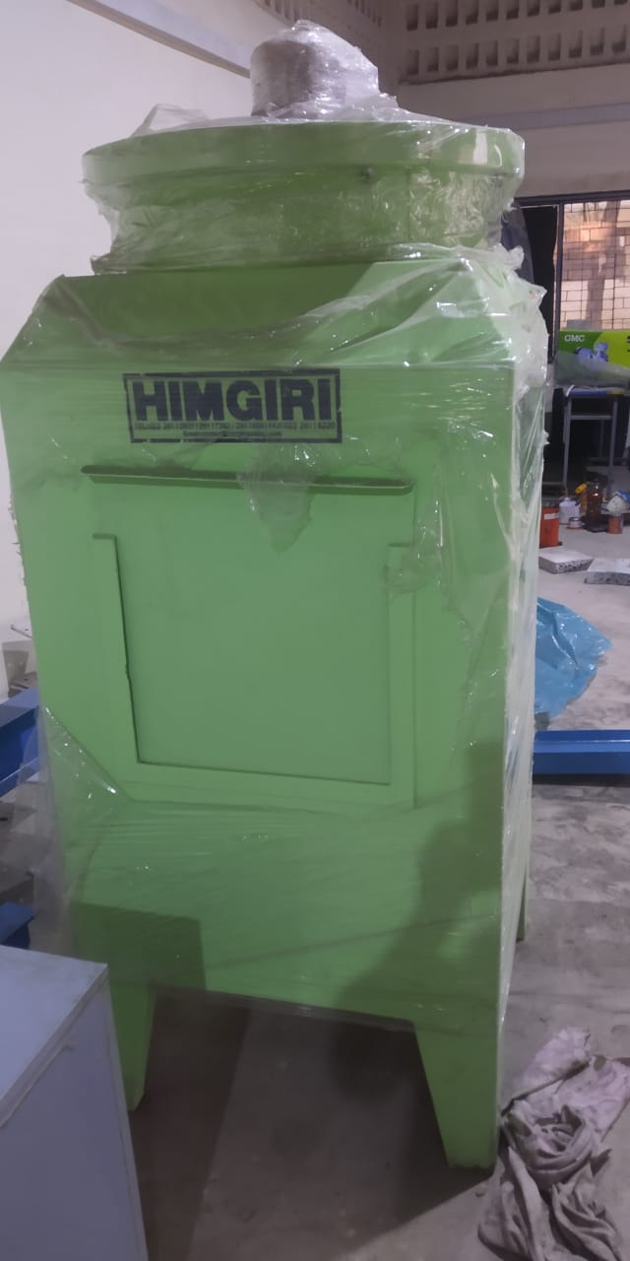
Figure 5 Water Cooling System
LIST OF EXPERIMENTS
Earthquake Resistant Design of Structures (CEST202) (M. Tech - Structural Engineering, Semester II)
Sr. No. | Title of Experiment
1 | RCC Beam Column Connection Testing under Cyclic Load
2 | Steel Beam Column Connection Testing under Cyclic Load
3 | Fatigue Test of beam Specimen
4 | Fatigue Test of RCC Slab
 | Other requisite research related testing

